Oliver V5 Top Most Popular resources report
Go to Circulation / Reports / Usage with search criteria
Enter the Start date and End date for the year (if you choose word format you can manipulate the results, if required) and choose ‘Most popular resources (with classification) report
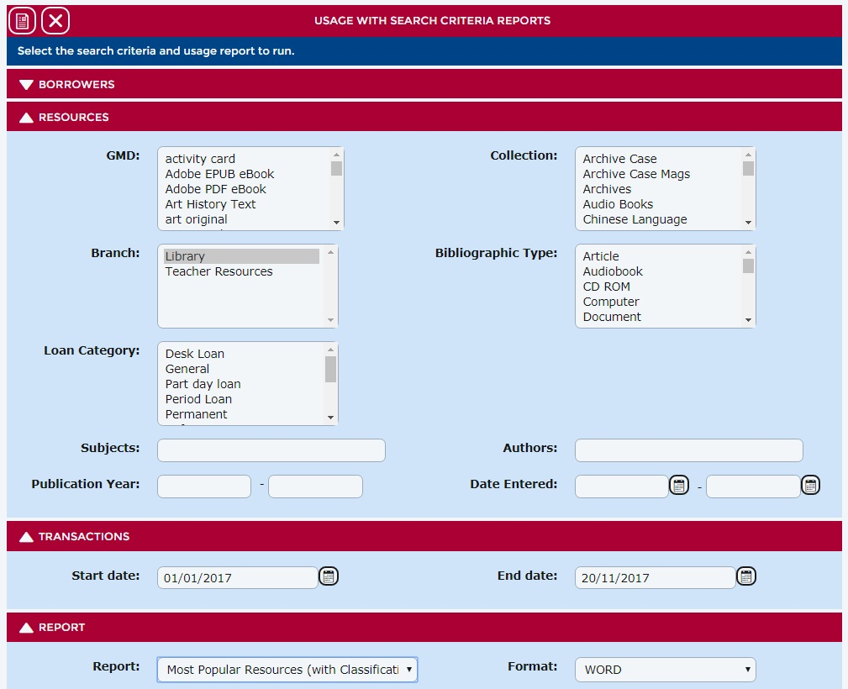

It may take some time to produce the report – be patient! It can also slow your system down so it is worth doing it at a time when others aren’t using Oliver and you can go and do other things.
This will give you the top 100 issues for the time period specified.
You should be able to work out your most popular series and author by looking through these results and totally the issues for each one.
To find the top five New Zealand books and authors can be difficult if they don’t appear in your top 100. It depends how your system is set up (I have created a subject heading ‘New Zealand author’ and all New Zealand titles have this as a subject heading, time consuming but worth it).
Trish Webster
Rangitoto College
trish.webster@rangitoto.school.nz

